**MATHEMATICS PAPER 1**

1. 2y + 3x – 8 = 0 B1 for re-arranging

2y = -3x + 8

y = x + 4

M1 =

From M1 M2 = -1, M2 = B1 for M2 =

= M1

=

6 = -2 + 2e

e = 4 A1

1. H = 2 (m – p2

= (m – p2

M1 for driving by 2

(= m- p2 and cubing both sides

= m – p2

P2 = m -

P = A1

P = M1

P =

P = 3 A for both values of p

1. Since =

S

A

T

C

Q is in the 3rd quadrat B1 sketch and correct quadrant

x = - 15

Q

-8

17

x M1 Proper use of Pythas Theoren theorem

x = don’t want

x = 15

cos Q = A1

tan Q =

= A1

1. p = Q = M1

PQ =

PQ = A1

det PQ = 6 – 4 = 2

inverse of PQ = ½ M1

= A1 for a final matrix after x by ½

1. 4x – y = 16

-4x + 6y = 12

= B1

= B1

=

= M1

20x = 108

x = 5.4

20y = 112

y = 5.6 A1

1. (3, 0) (0,5

Grand = = = - M1

y = mx + c

5 = 0 + c

C = 5

y = mx + c

y = - x +5

or 3y + 5x = 15 A1

Testing; with (0,0)

0 + 0 < 15

The inequality describing the unshaded region is 3y + 5x 15

1. Table of sums

|  |  |  |  |  |  |  |
| --- | --- | --- | --- | --- | --- | --- |
|  | 1 | 2 | 3 | 4 | 5 | 6 |
| 1 | 2 | 3 | 4 | 5 | 6 | 7 |
| 2 | 3 | 4 | 5 | 6 | 7 | 8 |
| 3 | 4 | 5 | 6 | 7 | 8 | 9 |
| 4 | 5 | 6 | 7 | 8 | 9 | 10 |
| 5 | 6 | 7 | 8 | 9 | 10 | 11 |
| 6 | 7 | 8 | 9 | 10 | 11 | 12 |

B2 for correct table

P(triangle number) =

= M1

= A1

1. Average of 35 girls = 60 M1

Average of 45 boys = 64

Average mark =

Total mark = average x no of students M1

For girls

Total mark = 35 x 60

= 2100

For boys

Total mark = 45 x 64

= 2880

Total mark for whole class of 80 is M1

2100 + 2880

= 4980

Average mark for the whole class

= 62.25 A1

A = M1

A = x x (4.5)2 M1

A =

A = 13.2589 A1

= 13.3000

Or 13.3 (3sf) A1

1. y = 2x2 – x + 1

y = 4x -2

2x2 – x + 1 = 4x -2

2x2 – x – 4x + 1 + 2 = 0 M1

2x2 – 5x + 3 = 0

2x2 – 2x – 3x + 3 = 0

2x(x -1) – 3 (x -1) = 0 M1

(x – 1) (2x – 3) = 0

x – 1 = 0 or 2x -3 = 0

x = 1 x = A1 for both values of x

y = 4 x 1 – 2 = 2

y = 4 x – 2 = 4

Points of intersection are (1, 2) and ( , 4)

1. A = 32

|  |  |  |  |  |  |  |  |
| --- | --- | --- | --- | --- | --- | --- | --- |
| Class boundary | Class | Tally | f | x | d | fd | cf |
| 95 – 14.5 | 10 – 14 | 11 | 2 | 12 | -20 | -40 | 2 |
| 14.5 – 19.5 | 15 - 19 | 111 | 3 | 17 | -15 | -4.5 | 5 |
| 19.5 – 24.5 | 20 – 24 | 1111 | 4 | 22 | -10 | -40 | 9 |
| 24.5 – 29.5 | 25 – 29 | ~~1111~~1 | 6 B1 | 27 B1 | -5B1 | -30 B1 | 15 B1 |
| 29.5 – 34.5 | 30 – 34 | ~~1111~~1 | 6 | 32 | 0 | 0 | 21 |
| 34.5 – 39.5 | 35 - 39 | ~~1111~~1111 | 9 | 37 | 5 | 45 | 30 |
| 39.5 – 44.5 | 40 -44 | ~~1111~~11 | 7 | 42 | 10 | 70 | 37 |
| 44.5 – 49.5 | 45 - 49 | 111 | 3 | 47 | 15 | 45 | 40 |
|  |  |  |  |  |  |  |  |

(b) Mode = Lm + ( ) i

= 34. 5 + ( ) x 5 M1

= 34.5 + 3

= 37.5 A1

(c) Mean = A +

= 32 + M1

= 32 + 0.125

= 32. 125 A1

(d) Median 33.5 0.5

= 33 – 34 B1

1. (a)

6.5

10

A

B

C

P

R

Q

5.2

Q

= M1

6.5 PQ = 52 M1

PQ =

= 8

PQ = 8cm A1

(ii) Sin =

Sin = 0.65

LPR = = 40.54160 M1

= 40.50 / 410 A1

(b)

13

13

5

h

h2 + 52 = 132  M1

h2 = 132 – 52

h = A1

h = 12

Volume = base area x h

= x x 52 x 12 M1

= 314. 2857 cm3 A1

(ii) L.S.F = 2

V.S.F = 23 = 8

Volume = 314.2857 x 8

= 2,514. 2856cm3

1. (a)

(-1, 0 )

(1, 0 )

(0, -1 )

(0, -1 )

1. T1 = B2

1. T2 = B2

(b) (i) M1

A1 (-2, -2), B1(-2, -6), C1 (-5, -6) A1

1. = M1

A11 (-2, 2), B11(-6, 2), C11 (-6, 5)

(c) Inverse of T2 T1 M1

T2 T1 = = A1

det T2 T1 = ( -1 x 1) – (0 x0) = -1

Inverse = M1

= A1

|  |  |  |  |  |  |  |  |  |  |
| --- | --- | --- | --- | --- | --- | --- | --- | --- | --- |
| x | -5 | -4 | -3 | -2 | -1 | 0 | 1 | 2 | 3 |
| 10 | 10 | 10 | 10 | 10 | 10 | 10 | 10 | 10 | 10 |
| -2x | 10 | 8 | 6 | 4 | 2 | 0 | -2 | -4 | -6 |
| -x2 | -25 | -16 | -9 | -4 | -1 | 0 | -1 | -4 | -9 |
| y | -5 | 2 | 7 | 10 | 11 | 10 | 7 | 2 | -5 |

1. (i) Max value = 11

(ii) Equation of the line of symmetry

(b) (i) To solve 10 -2x – x2 = 0

10 – 2x – x2 = y

y = 0

x = 2.3 0.1, x = -4.3 0.1

x 2.2 – 2.4

x - 4.4 – 4.2

(ii) 4 – 3x – x2 = 0

-10 – 2x – x2 = y

-6 + x = y

(0, 6), (-6, 0)

1. 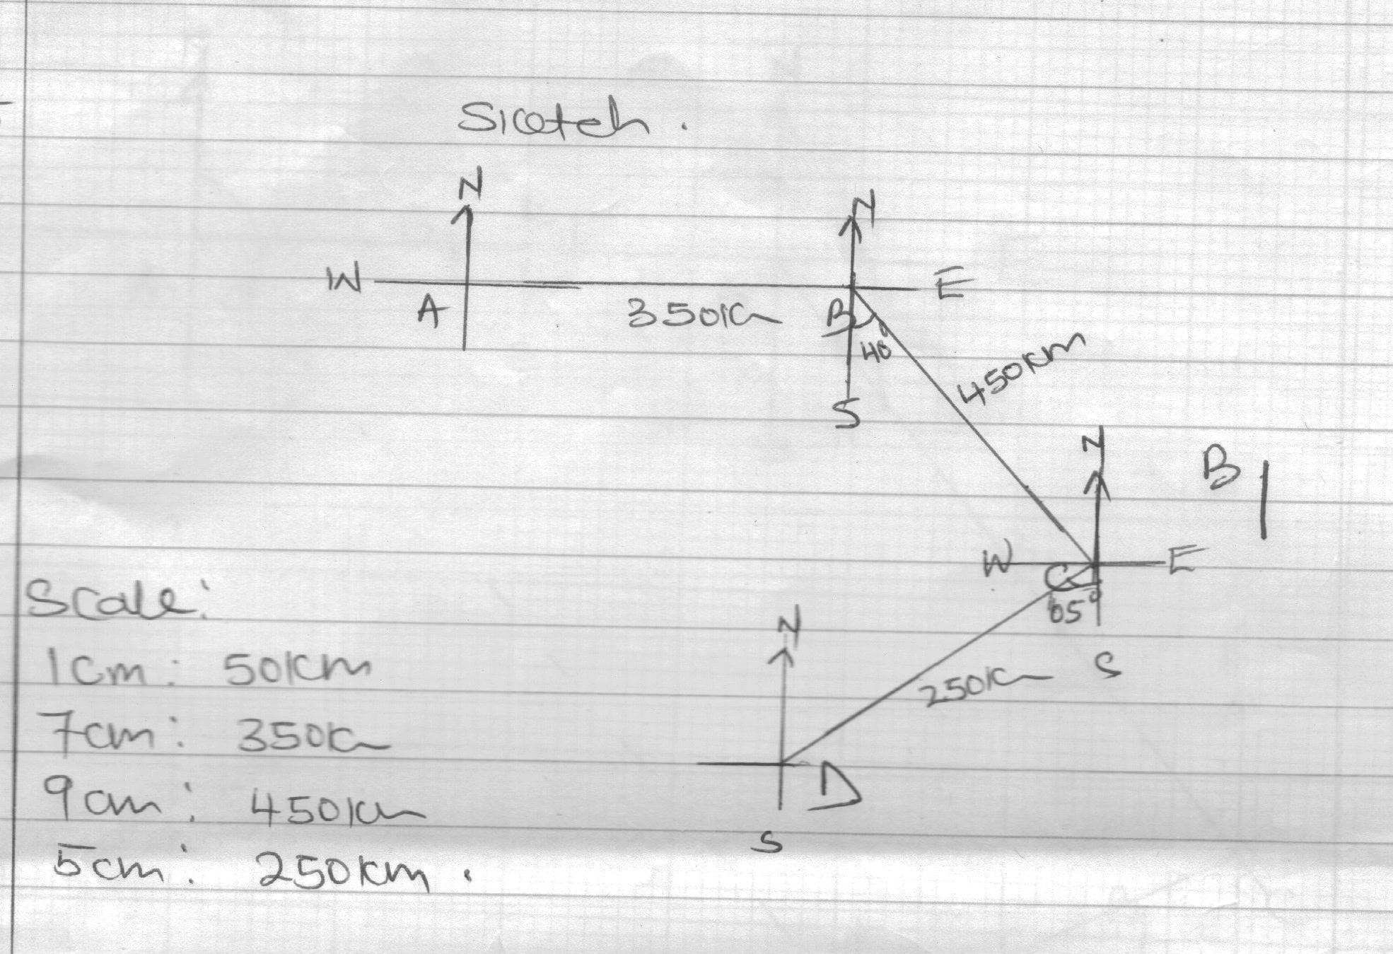

Accurate drawing, see graph

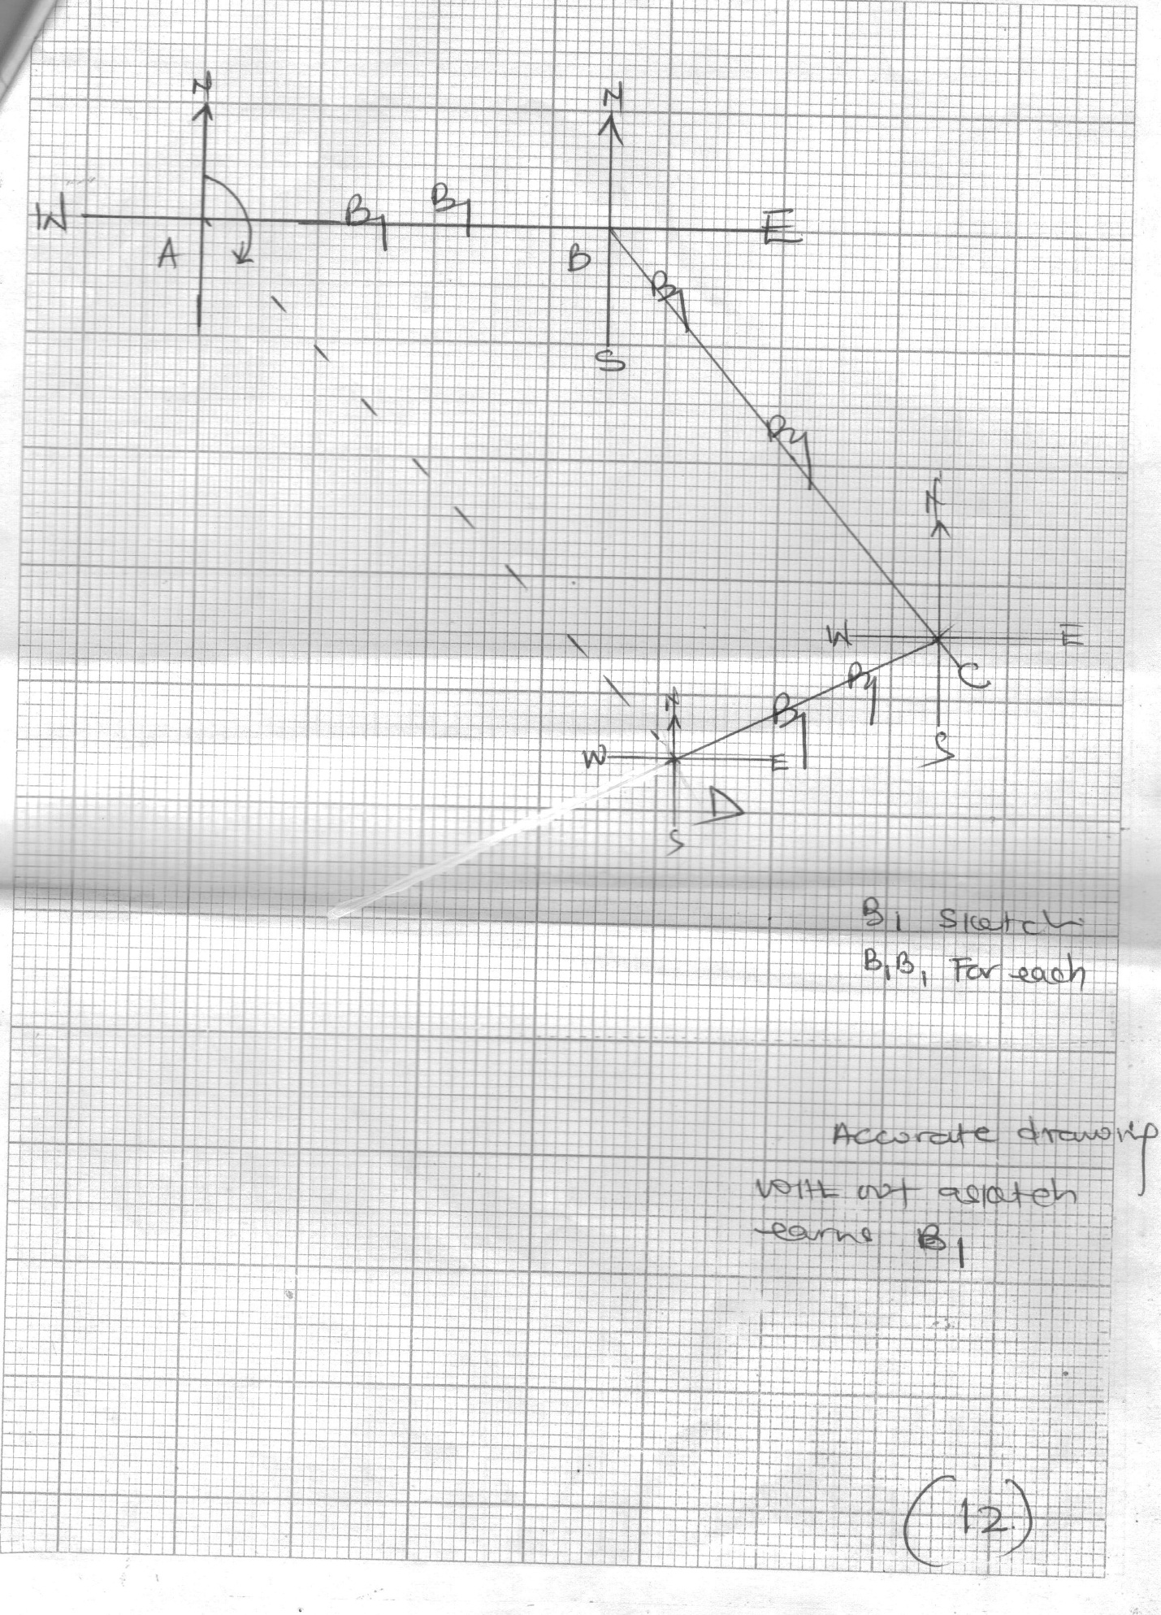

1. OA = 12.3 0.1

12.2, 12.3, 12.4

= 610km, 615km, 620km

Speed =

= = 205km/hr 2 M1

203 – 207 kmhr A1

1. Bearing of D from A

1380 20

1360 - 1400 B2

1. (a)

(i) {345, 354, 435, 453, 534, 543} B2

(ii) Prob = B1

=

= A1

(b) Let F be the event that Ouma is selected for foot ball and V that he is selected for volley ball

P(F) = , P(F1) = B1

P(V) = , P(V1) = B1

(i) P(F1 and V1) = P(F1) x P(V1) M1

= x M1

= A1

(ii) P(F1 and V) = P(F1) x P(V1)

= x M1

= A1

1. (a) 3x + 4y 24 …………………………. (i) B1

200,000 x + 100,000 y 600, 000 ……... (ii) B1

2x + y 6

x > 0 …………………………………….. (iii) B1

y >0 ……………………………………. ( iv) B1

Boundary lines

3 x + 4y = 24

(0,6) ( 8, 0)

2 x + y = 6

(0,6) (3,0) N.B x and y must be dotted

(c) The greatest number of machines he would buy was 7 A1

(d) Optimal sol

Profit 15,000 x + 18,000 y

(1,6) = 15,000 + 108,000 = 123,000/=

(5,2) = 75,000 + 36,000 = 111,000/= M1

(4,3) = 60,000 + 54,000 = 114,000/=

The greatest profit is shs 123,000 he was to use 1 type x machine and 6 type y machines in order to fetch the greatest profits. A1